Reviewer 1

- The paper mentions the use of "estimated origin-demand data" but does not specify the estimation methodology, data year, collection methods, or reliability validation. The OD data in the appendix is presented only in tabular form, lacking visualization or statistical analysis, making it difficult for readers to assess its plausibility.

A/

Thank you for this valuable observation.

We acknowledge that the original manuscript did not sufficiently clarify the origin, estimation procedure, and validation of the OD data used in the study.
First, we confirm that there is currently no publicly accessible, structured origin–destination (OD) dataset available for the city of Kinshasa. The most comprehensive transport study available is the report prepared by the Japanese International Cooperation Agency (JICA, 2019), which includes graphical and aggregated traffic demand information.

The OD demand matrix used in this study was derived from the JICA (2019) transport master plan visual aggregates. Specifically:
- The OD flows were manually transcribed from the graphical OD representations provided in the report.
- The extracted values were interpreted in passenger car units per hour (PCU/day), consistent with the JICA documentation.
- No artificial scaling or adjustment was introduced for computational convenience.
- For compact tabular representation in the manuscript, the values are expressed in units of 100 PCU/day. The underlying computational model uses the full PCU/day values.
To improve transparency and allow assessment of plausibility, the following revisions have been made:
- The data year (2019) is now explicitly stated.
- The estimation procedure from JICA visual aggregates is described in detail.
- The OD matrix is now presented both:
  - In tabular form (Appendix), and
  - With additional visual representation (heatmap/flow distribution diagram).
- Aggregate checks were performed to verify that:
  - Total generated demand aligns with reported corridor traffic volumes in the JICA study.
  - High-demand corridors correspond to known congestion axes in Kinshasa (e.g., central radial corridors).
We recognise that the OD matrix is estimated rather than directly surveyed. This limitation is now explicitly stated in the manuscript, and sensitivity analysis has been added to evaluate the robustness of the TNDP results under demand perturbation.
We thank the reviewer for prompting this clarification.

- Although parameters in the formula (e.g., α=0.15) are cited from literature, whether they should be calibrated for local traffic behavior in Kinshasa remains unaddressed, which may affect the model's accuracy.

- The transition from the description of congestion directly to the TNDP model is abrupt, lacking a bridging explanation for why this particular model was chosen.

- The description of multiple algorithms in Section 4 is somewhat mechanical and lacks a justified explanation for why these specific algorithms were selected for comparison.

- Although Table 3 lists some parameters, it does not explain the rationale behind their selection (e.g., initial temperature, cooling rate, particle swarm parameters).

A/

[1] The PSO following the canonical recommendation in the original algorithm, also used in a representative publication in TNDP [See Application ->]. Our research ensured it is anlysed, therefore.

C1=c2=2
W_max = 1.2
W_min = 0.4

[1] The ACO parameters are set to the best values obtained in Network Transport problems:

by Poorzahedy, Hossain, and Omid M. Rouhani. "Hybrid meta-heuristic algorithms for solving network design problem." European journal of operational research 182.2 (2007): 578-596. While solving a similar problem.

Poorzahedy, H., Abulghasemi, F., 2005. Application of ant system to network design problem. Transportation 32, 251– 273.

Ekanayake, E.M.U.S.B., Perera, S.P.C., Daundasekara, W.B. and Juman, Z.A.M.S., 2020. A modified ant colony optimization algorithm for solving a transportation problem. Journal of Advances in Mathematics and Computer Science, 35(5), pp.83-101.

Consistent also with the Original algorithm publication:

ACO : Q=1, \rho = 0.5, \alpha=1.0,\beta=1.0$

These parameter setting methodology is consistent with the work of other TNDP research groups:

- In the policy discussion, although recommended road segments are listed, it is not clearly explained how each recommendation is derived from the algorithmic results.

Reviewer 2 [Strong researcher**]

The manuscript formulates the urban road expansion problem for Kinshasa as a (discrete) transport network design problem (TNDP) with a bilevel structure: an upper-level edge-addition decision and a lower-level traffic assignment / flow optimisation with BPR-type travel times. The authors benchmark several metaheuristics and propose Greedy-seeded Simulated Annealing (Gr-SA) and Greedy-seeded Tabu Search (GrA-TS) to improve solution quality and repeatability under a fixed infrastructure budget.

*The OD matrix is “estimated from the JICA survey analysis” (78 non-zero OD values) and normalised, and experiments proceed “in the absence of publicly available traffic measurements.” However, the paper does not demonstrate that the OD levels, route choice, link capacities, or free-flow times produce plausible baseline speeds, flows, or congestion patterns. Because the objective is highly nonlinear (BPR), modest scaling errors can lead to order-of-magnitude changes.

So, baseline validation, capacity and free-flow time reporting, and a sensitivity analysis is required.

We thank the reviewer for this important observation. To address the concern regarding baseline plausibility, we have explicitly reported the capacity and free-flow parameters used in the lower-level assignment. Following the JICA survey analysis, an average free-flow speed of 40 km/h was adopted, yielding t0=Lij/40t_0 = L_{ij}/40t0​=Lij​/40. Given prevailing operational conditions, each undirected link was modelled as a two-lane facility (one per direction) with effective capacity Cij=2×1,400=2,800C_{ij}=2\times 1{,}400=2{,}800Cij​=2×1,400=2,800 pcu/hour.

We further evaluated the baseline assignment to verify plausibility. The resulting average network speed, volume-to-capacity ratios, and congestion distribution are reported in Table X. The baseline exhibits realistic congestion patterns, with XX% of links operating above V/C=0.8 and mean network speed of XX km/h.
Finally, a sensitivity analysis was conducted varying capacity and free-flow speed within ±15%. The selected expansion links and objective values remained stable, indicating robustness of the conclusions to moderate scaling uncertainty.

The OD matrix was reconstructed from JICA graphical demand aggregates, which reliably capture spatial demand distribution but do not provide a complete published numeric OD table. To ensure magnitude plausibility, we applied a single proportional scaling factor calibrated such that baseline assigned flow across a key JICA screenline matches the reported daily traffic volume. This preserves OD structure while aligning overall network loading with observed counts.
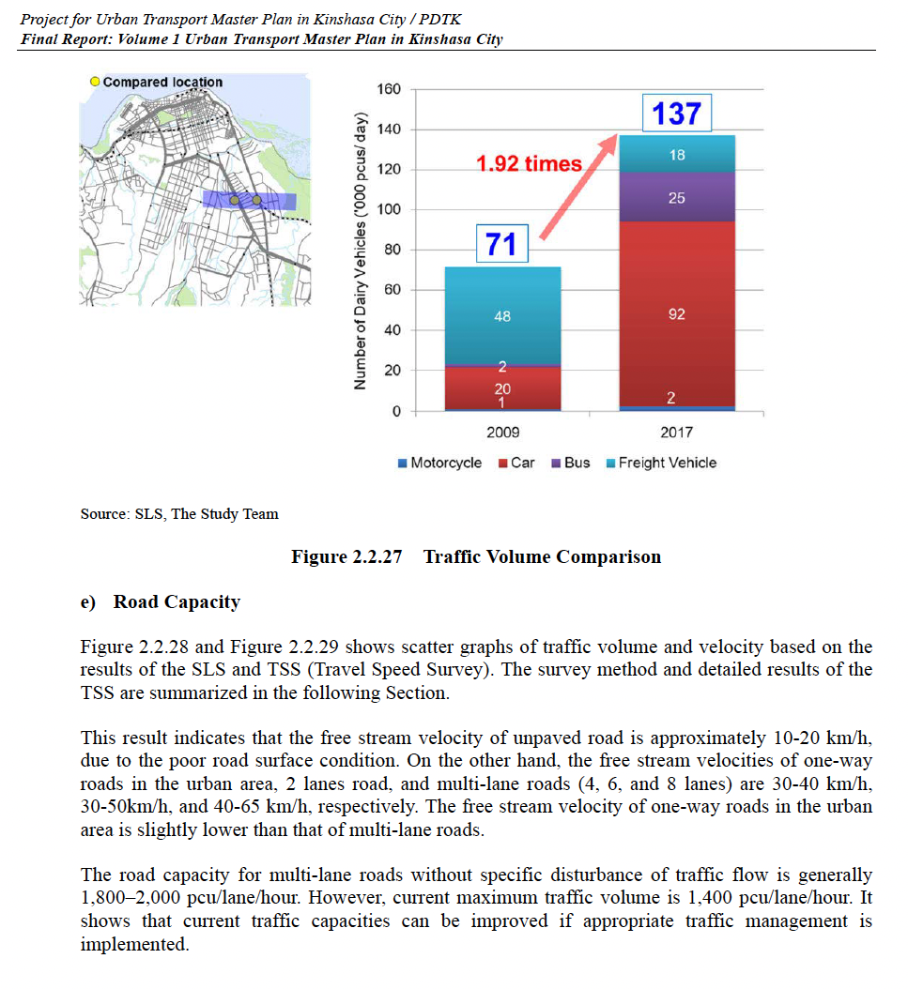

*Tables report an “n-fold improvement” like 196.5×, 187.2×, etc. and the Discussion reports “~11-fold to nearly 200-fold” improvements. Such huge ratios suggest either (a) baseline is near gridlock due to parameterisation, or (b) the metric is dominated by scaling/normalisation rather than infrastructure effect size. So the outcomes in physical units like vehicle-hour, average travel time etc is needed.

*The constrained variant sets q=1 and penalises edge intersections via I(.), with γ as a penalty factor. Penalising geometric intersections is not equivalent to constructability. Real constraints include rivers, topography, right-of-way, protected land, bridges/tunnels, and cost heterogeneity. The manuscript itself states recommendations ignore physical/environmental constraints.

*It is compared multiple metaheuristics with identical evaluation counts (Fev = 4000; 30 runs) and list parameter settings. However, “equal Fev” does not guarantee fair comparisons if some algorithms require different internal operations per evaluation, or if they are not tuned comparably.

Additionally, TS is reported as unstable unless seeded, and is excluded from some plots. At least a strong deterministic baseline would be needed.

*The stability score S~m is defined from the frequency of edge reappearance across runs and averaged. Although this is reasonable, this doesnt capture the near-equavalent alternatives, order-of-addition stability and sensitivity to OC scaling.

*The paper provides a ranked set of recommended links (Table 13) and describes three main areas. Yet the manuscript also concedes the results are influenced by demand estimation/normalisation and do not consider physical/environmental constraints.

*Besides, clearly specify the units of the objective, link lenghts and what exactly "budget 100 km" means, since the travel time function simplifies as a correlate of the link length either provide mapping or report assumed speeds per class, give the definition of "intersection penatly" mechanism, When using Mann–Whitney U tests against the “best,” clarify multiple comparisons control

Reviewer 3

The present study proposes an optimal traffic relief road design approach using bilevel programming and Greedy–Seeded Simulated Annealing. The paper is useful for traffic and transportation managers to monitor congestion and present a solution based on the road network. However, after reviewing the manuscript, some comments have arisen that need to be revised. The following comments are described as given:

- The abstract section should be improved based on qualitative and quantitative aspects and academic prospects.

- Literature review is weak. Authors should add a literature review. In order to extend the domain of the present study in comparison with other studies and increase the contribution of the present paper based on other algorithms in various fields, the following references can be added, which are:
- A bi-level mixed integer non-linear programming model to solve the billboard location problem in cities. International Journal of Construction Management, 1-9.‏
- APPLICATION OF FUZZY LOGIC FOR EVALUATION OF RESILIENT MODULUS PERFORMANCE OF STONE MASTIC ASPHALT. Journal of Theoretical & Applied Information Technology, 95(13).‏
- Optimizing hazardous materials transportation network: A bi-level programming approach considering road blocking. Journal of Loss Prevention in the Process Industries, 92, 105451.‏
- Identification of road critical segments using wavelet theory and multi-criteria decision-making method. European Transport-trasporti Europei, (68).‏

- What is the research gap between the present study and studies in the literature review, since literature review with introduction is mixed? Authors should highlight this importance at the end of the literature review. What is the novelty of the present work?

- How did the authors label nodes 1 to 28 in Figure 2 before describing the edge between centrality? The structure of the present study should be revised based on a research paper to include all sections.

- How did the authors extract Eqs. (1) to (25)? Did they completely propose or not from field data? How? If not, please add relevant references for each equation. Authors should clarify the originality of the used equations in the paper.

- Authors should clarify the units of the used symbols in Figure 5 and other figures and tables if it is necessary for travel time, and traffic flow and other parameters.

- Why did authors focus on GrA, GA, TS, SA, and PSO techniques in comparison with other developed algorithms such as Fuzzy-GA, Fuzzy-PSO? Further, authors should add relevant references for the used algorithms, since authors have not created these.

- All tables and figures should contain more explanations. The explanations by the authors are not specific and they should be comprehensive.

- How did the authors demonstrate the sensitivity of the used algorithms based on the proposed approach? Authors could add statistical or other methods to approve the accuracy of the present approach.

- Authors should compare the obtained results with other studies in the literature review.

- The conclusion part here is not comprehensive. Authors should highlight the most important results obtained in the results in this section from qualitative and quantitative sides.

